 | 7.0.21 Editors - 3D Viewport - Hair Curves - Edit Mode - Curves context menu
Table of content
Detailed table of collection 1
Edit Mode - Curves Context Menu 3
Subdivide 3
Extrude Curve and Move 3
Mirror sub menu 4
Snap sub menu 5
Set Spline Type 6
Set Handle Type 7
Toggle Cyclic 7
Switch Direction 7
Separate 8
Delete 8
Split 8

Detailed table of collection

Detailed table of content
Detailed table of collection 1
Edit Mode - Curves Context Menu 3
Subdivide 3
Last Operator Subdivide 3
Number of Cuts 3
Extrude Curve and Move 3
Last operator Extrude Curve and Move 3
Mode 3
Move X , Y , Z 3
Orientation 4
Mirror Editing 4
Proportional editing 4
Proportional Falloff 4
Proportional Size 4
Connected 4
Projected(2D) 4
Mirror sub menu 4
Interactive Mirror 4
Usage: 4
X Y Z Global 4
X Y Z Local 4
Last Operator Mirror 5
Orientation 5
Proportional editing 5
Proportional Falloff 5
Proportional Size 5
Connected 5
Projected(2D) 5
Snap sub menu 5
Selection to Cursor 5
Selection to Cursor(Keep Offset) 5
Last operator Snap Selection to Cursor 5
Offset 5
Rotation 6
Selection to Active 6
Selection to Grid 6
Cursor to Selected 6
Cursor to World Origin 6
Cursor to Active 6
Cursor to Grid 6
Set Spline Type 6
Last Operator Set Spline Type 6
Type 6
Handles 6
Set Handle Type 7
Auto 7
Vector 7
Align 7
Free 7
Toggle Free/Aligned 7
Last Operator Set Handle Type 7
Type 7
Toggle Cyclic 7
Last Operator Toggle Cyclic 7
Direction 7
Switch Direction 7
Separate 8
Delete 8
Split 8

Edit Mode - Curves Context Menu
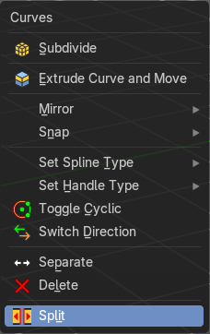
Call this menu with double right click in the 3D viewport. You need to be in Edit mode with a armature object.

Subdivide
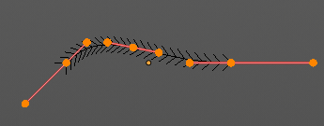
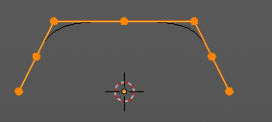
Subdivides the selected curve geometry, and adds more control points.

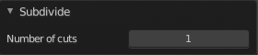
Last Operator Subdivide

Number of Cuts
Number of subdivision cuts.

Extrude Curve and Move
Extrudes the selected curve point(s).

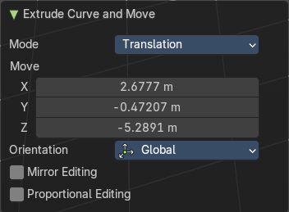
Last operator Extrude Curve and Move

Mode
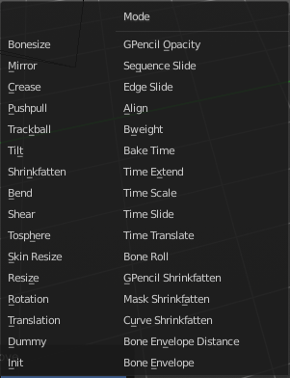
A drop-down box where you can choose between different extrude modes.
Default is Translation. Most other methods has no effect.

Move X , Y , Z
The position of the extruded point(s).

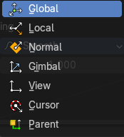
Orientation
Adjust the orientation of the extrusion. It usually starts with Normal.

Mirror Editing
Enable Mirror Editing.

Proportional editing
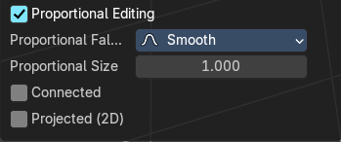
Enables proportional editing. Activating proportional editing reveals further settings.

Proportional Falloff
Adjust the falloff methods.

Proportional Size
See and adjust the falloff radius.

Connected
The proportional falloff gets calculated for connected parts only.

Projected(2D)
The proportional falloff gets calculated in the screen space. Depth doesn't play a role. When it's in the radius, then it gets calculated.

Mirror sub menu
Mirrors the selection.

Interactive Mirror
Mirrors the selection.

Usage:
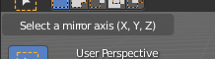
Activate the tool. In the header you will now see further instructions. Which is: type in the axis at which you want to mirror. Interactive mirroring starts in Global space. You can change the orientation in the last operator.

X Y Z Global
Mirrors along the global axis.

X Y Z Local
Mirrors along the object axis.

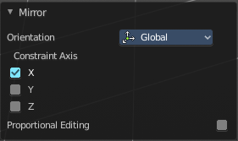
Last Operator Mirror


Orientation
Choose the orientation in which the transform should happen.

Proportional editing
Enables proportional editing. Activating proportional editing reveals further settings.

Proportional Falloff
Adjust the falloff methods.

Proportional Size
See and adjust the falloff radius.

Connected
The proportional falloff gets calculated for connected parts only.

Projected(2D)
The proportional falloff gets calculated in the screen space. Depth doesn't play a role. When it's in the radius, then it gets calculated.

Snap sub menu

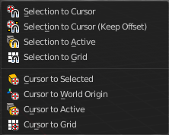
Selection to Cursor
Snaps the currently selected object(s) to the cursor location.

Selection to Cursor(Keep Offset)
Snaps the currently selected object(s) to the cursor location, but keeps the offset of the selected objects to each other. Means the center of the current selection goes to cursor position. Not every individual object.

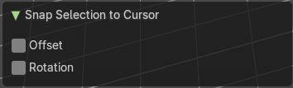
Last operator Snap Selection to Cursor

Offset
Keep the offset of the selected objects to each other.

Rotation
Rotate to match the cursor.

Selection to Active
Snaps the currently selected object(s) to the active object.

Selection to Grid
Snaps the currently selected object(s) to the nearest grid point.

Cursor to Selected
Moves the cursor to the center of the selected object(s).

Cursor to World Origin
Moves the cursor to the world origin.

Cursor to Active
Moves the cursor to the center of the active object.

Cursor to Grid
Moves the cursor to the nearest grid point.

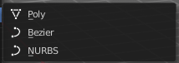
Set Spline Type
With set Spline Type you can set the type of the curve.
Poly is a straight line between the control points. Bezier has curve handlers. A nurbs curve has a control cage.




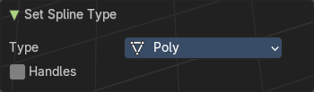
Last Operator Set Spline Type

Type
Type is a drop-down box choose the spline type

Handles
Use Handles when converting Bezier curves into polygons.

Set Handle Type
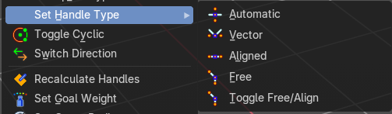
Handles defines the type of handle for the knots of the curve. You have the choice between Auto, Vector, Align and Free. And the Last Operator gives you a fifth possibility to toggle between Free and Align.

Auto
Auto aligns the handles automatically.

Vector
Set Handle type to Vector.

Align
Set Handle type to Align.


Free
Set Handle type to Free.

Toggle Free/Aligned
Toggle Free/Aligned.


Last Operator Set Handle Type

Type
Type is a drop-down box where you can set the handle type. You have the choice between Auto, Vector, Align, Free. And the fifth possibility toggles between Free and Align.

Toggle Cyclic

Toggle Cyclic closes or opens the curve.

Last Operator Toggle Cyclic

Direction
Direction is a drop-down box choose the direction in which the curve gets closed.

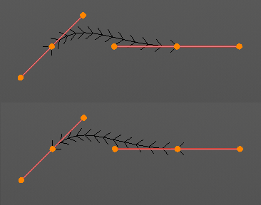
Switch Direction
Just for Bezier Curve object type. Surface Nurbs curves doesn't have a direction. Switches the direction in which the curve is pointing.

Separate
Separates the selected control points, and creates a new curve object out of it. You need to select two control points to select the segment between it.

Delete
Removes the selected control points or curves.

Split
Split selected points into a new object.

